

**Green University of Bangladesh**

**Department of Computer Science and Engineering (CSE)**

**Faculty of Sciences and Engineering**

**Semester: (Summer, Year: 2022), BSC in CSE (Day)**

**Course Title: Structured Programming**

**Course Code: CSE 103 Section: 221D4**

**Assignment**

**Student Details**

| **Name** | | **ID** |
| --- | --- | --- |
| **1.** | Md. Maruf Sarker | 221002063 |

**Submission Date: 11 September, 2022**

**Course Teacher’s Name: Humayan Kabir Rana**

**[For Teachers use only: Don’t Write Anything inside this box]**

| **Lab Project Status**  **Marks: ………………………………… Signature: .....................**  **Comments: .............................................. Date: ..............................** |
| --- |

**Task-1:**

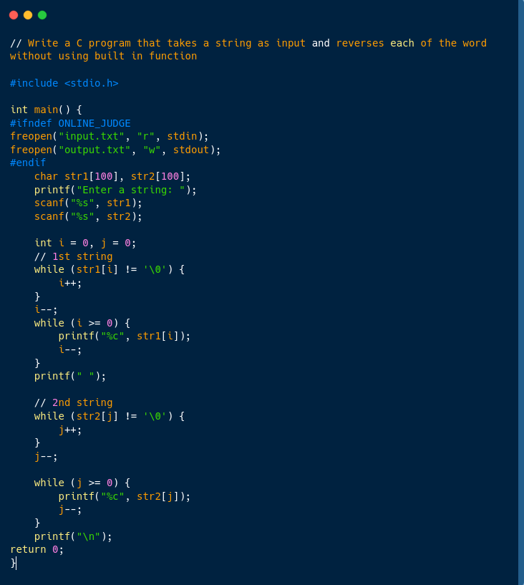

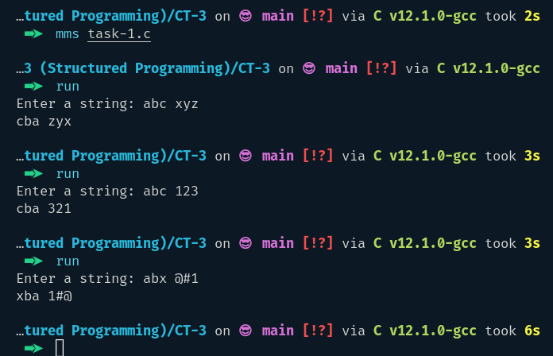

**Task-2:**

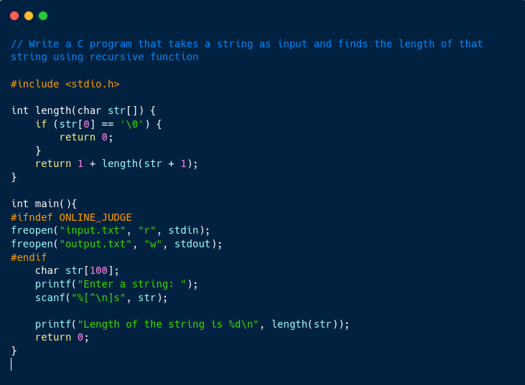

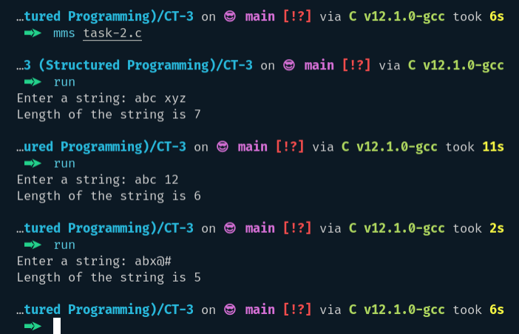

**Task-4:**

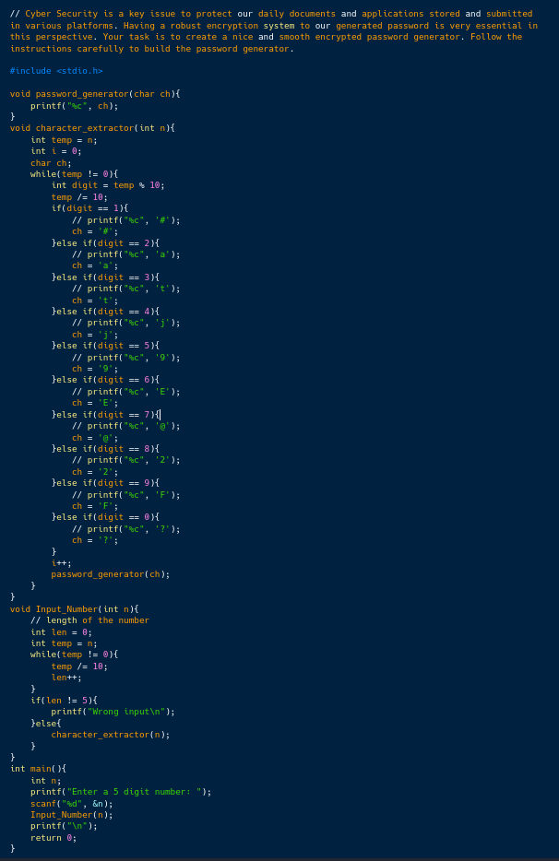

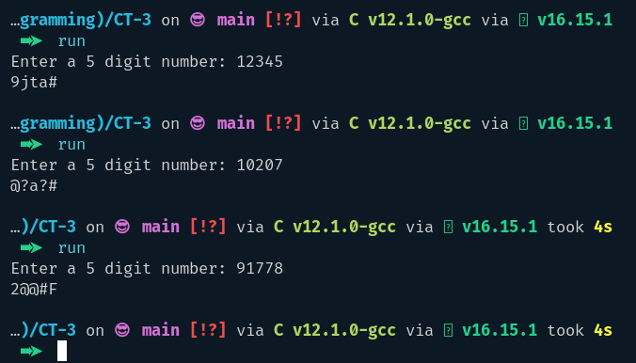

**Task-5:**

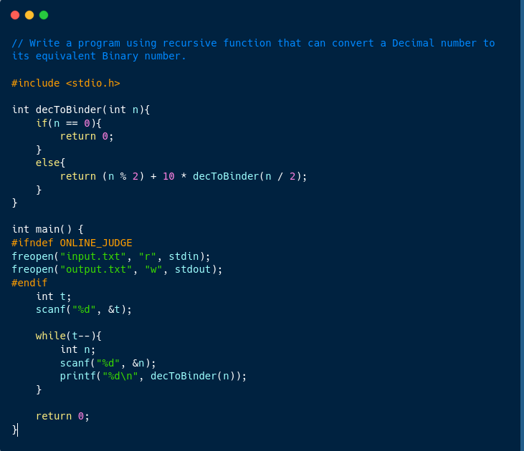

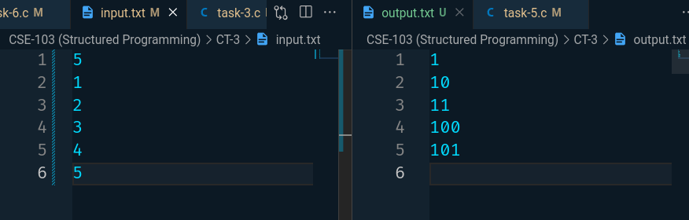

**Task-6:**

